New Hampshire Right to Life


Post Office Box 421 Merrimack NH 03054
603.626.7950 life@nhrtl.org www.nhrtl.org
NHRTL-PAC

July 7, 2005

Dear Legislator:

In appreciation for your legislative pro-life work, NHRTL-PAC is pleased to invite you, your family, and your friends to the Third Annual pro-life picnic! Join us on Sunday afternoon,
July 31, from 2pm to 7pm at Pawtuckaway State Park in Nottingham, NH for a great time with NH pro-lifers.

This picnic will feature lots of family fun with games like batmitton, potato sack races, frisbee, croquet, water balloon tosses, face painting, raffles, and music. The park slides, swings, and life-guarded beach are also available for use.

Bring your own meat and rolls and bring a salad or dessert to share. NHRTL-PAC will cover the normal donation cost for you and up to three family members for the provided drinks, ice, snacks/chips, and watermelon. A grill, all paper products, utensils, and condiments will be provided too.

The State Park has an entrance fee of $3 for each adult, $1 per child aged 6 to 11. Children under 5, NH residents age 65 and over, and State Legislators should be allowed in free. We have reserved the huge pavilion again. You can see photos of past picnics on line at www.nhrtl.org/picnic/2004 or www.nhrtl.org/picnic/2003

Pawtuckaway State Park is about 15 miles Northeast of Manchester – about 4 miles
north of Raymond in Nottingham, NH. Exact directions are on-line at www.nhrtl.org/picnic/2005 From the west, take I-93 to Route 101, Exit 5 (Raymond). From the east, take I-95 to Route 101, Exit 5. Upon taking Exit 5, head north on Route 107, past the McDonald’s. Turn left at the Tee and then take a quick right onto Nottingham Road. Follow the NHRTL signs about 3 miles to Pawtuckaway State Park.

We request your RSVPs by leaving a message at 626-7950 or by sending an e-mail to life@nhrtl.org Please provide your full name, telephone number, and mailing address with your RSVP before July 23. Please join us for what will be a memorable event of friendship, fun, and food!

Many thanks,
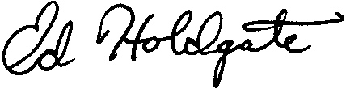
Ed Holdgate
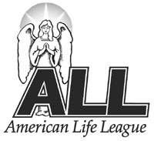 An Associate of American Life League, Inc.
NHRTL-PAC President

