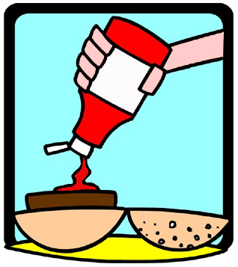
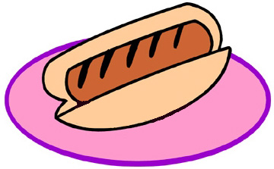

Calling New Hampshire Pro-lifers!!!

NHRTL invites you to the Third Annual NH Right to Life Picnic on
Sunday, July 31, 2pm to 7pm, at Pawtuckaway State Park. This
picnic features terrific family fun with games like batmitton,
frisbee, sack races, croquet, and water balloon tosses!
Get face painted and use the park slides, swings, and
life-guarded beach if you want!

Bring your own meat and rolls and bring a salad or dessert dish to
share. A $5 per person donation to NHRTL will cover the drinks,
ice, snacks/chips, and watermelon. A grill, all paper products, utensils,
and condiments will be provided too. Additionally, you will be charged
the normal Pawtuckaway State Park Admission of $3 per person over 11 and
$1 per child aged 6 to 11 in cash at the park entrance gate.

We have reserved the huge pavilion again. You can see photos of the fun pro-lifers had in the past at www.nhrtl.org/picnic/2004 or www.nhrtl.org/picnic/2003

Pawtuckaway is about 15 miles North-east of Manchester -- about 4 miles North of Raymond in Nottingham, NH. Take Route 101 to Exit 5. Go north when you get off Exit 5. Go past the McDonald’s to the Tee. Turn left at the Tee and then a quick right onto Nottingham Road. Follow the NHRTL signs about 3 miles to the park. Exact directions are on-line at www.nhrtl.org/picnic/2005





We request your RSVP by e-mail to life@nhrtl.org or by a
telephone call to 626-7950 before JULY 23. We will plan the drinks, etc., based on the RSVP that come in. Please provide your
full name, telephone, and mailing address with your RSVP.
Thank you!

Ed Holdgate
NHRTL Pres.


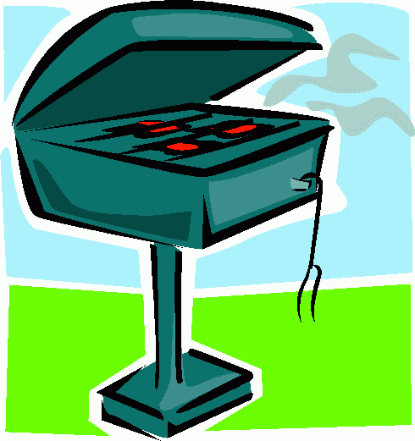

NH RIGHT TO LIFE
Box 421 Merrimack 03054
626-7950 life@nhrtl.org
www.nhrtl.org
See our website for details and maps.
PLEASE COPY THIS & DISTRIBUTE!

