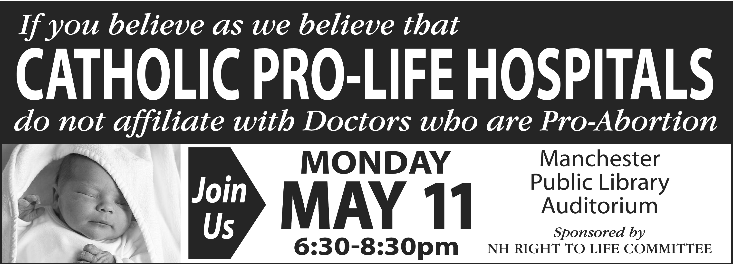

NHRTL Public Session to Alert the Public to Take Actions to Keep
Catholic Medical Center a Pro-life Healthcare Facility in NH

Manchester Public Library on Monday, May 11th, 6:30 to 8:30

The Honorable Kathy Souza, NHRTL Legislative Chair, and the Honorable Barbara Hagan will lead a public meeting to inform interested citizens about the proposed Catholic Medical Center [CMC]-Dartmouth Hitchcock [D-H] liaison and our concerns for pro-life healthcare in New Hampshire.

NHRTL works to ensure that pro-life healthcare is available in our state and thus is very concerned with the proposed affiliation. D-H is part of a network in Lebanon, N.H, with ties to Dartmouth Medical School and Mary-Hitchcock Hospital.

D-H has a record of involvement with abortion -- performing, referring for, prescribing abortifacients, training doctors in abortion, opposing both NHRTL and the Catholic Diocese before the N. H. legislature on both beginning-of-life and end-of-life issues, is involved with fertility programs that are anti-life -- selective reduction, embryonic stem-cell research, advocates for the destruction of "unfit" embryos, etc.

That CMC, a Catholic pro-life hospital which shares the pro-life principles of NHRTL, would entertain a liaison with one whose pro-life ethics are diametrically opposed, is a grave concern. We've fought this battle before [remember Optima] and won, but we need many people informed and active.

Please attend this highly informative session at the Manchester Public Library on Monday. May 11th, 6:30 to 8:30

New Hampshire Right To Life
POBox 421, Merrimack, NH 03054
(603) 626-7950 www.nhrtl.org life@nhrtl.org
5/1/09

